**Dashboard User Manual**

1. **Home Page**

The dashboard will give an overview of the critical issues on all projects but the use of filters will allow you to identify the details of the individual project.

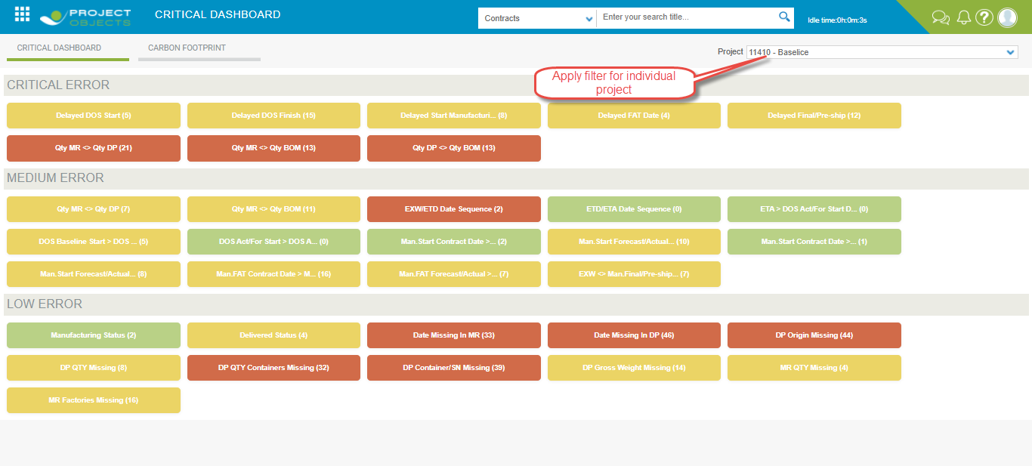

In the dashboard, all tiles are divided into three sections-

1. Critical Error
2. Medium Error
3. Low Error
4. **Critical Error**

This section will list all errors that are of high priority to monitor. We discuss one by one tiles in the critical error section.

1. **Delayed DOS Start**

In this tiles, we will count all the lines where there is a delay

The delay means when:

DOS forecast START - DOS baseline START >0.

If at least one of the 2 dates is not present it should not be counted as a delay line.

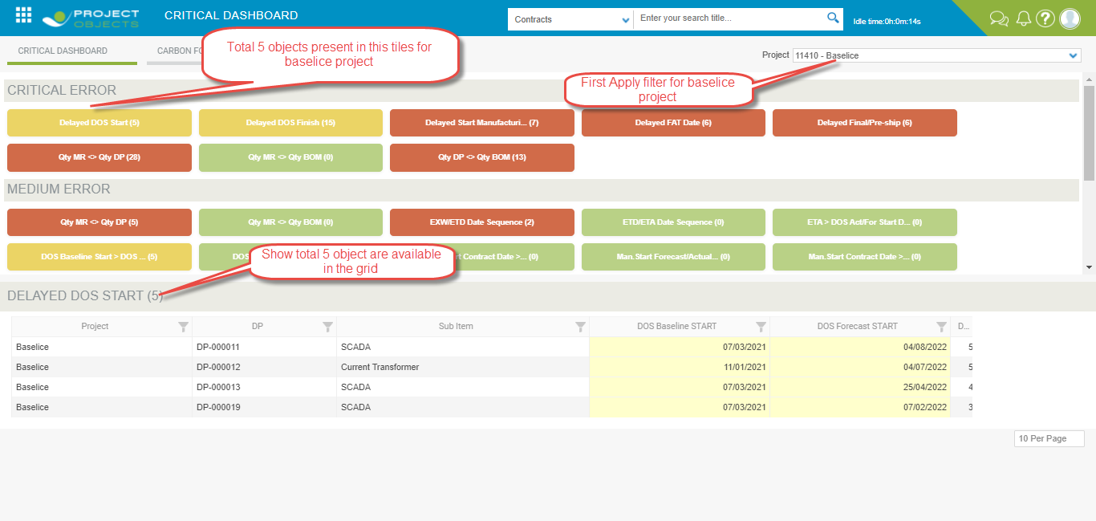

* Change date in Forecast Baseline start and Forecast Baseline start < DOS baseline start and click apply.

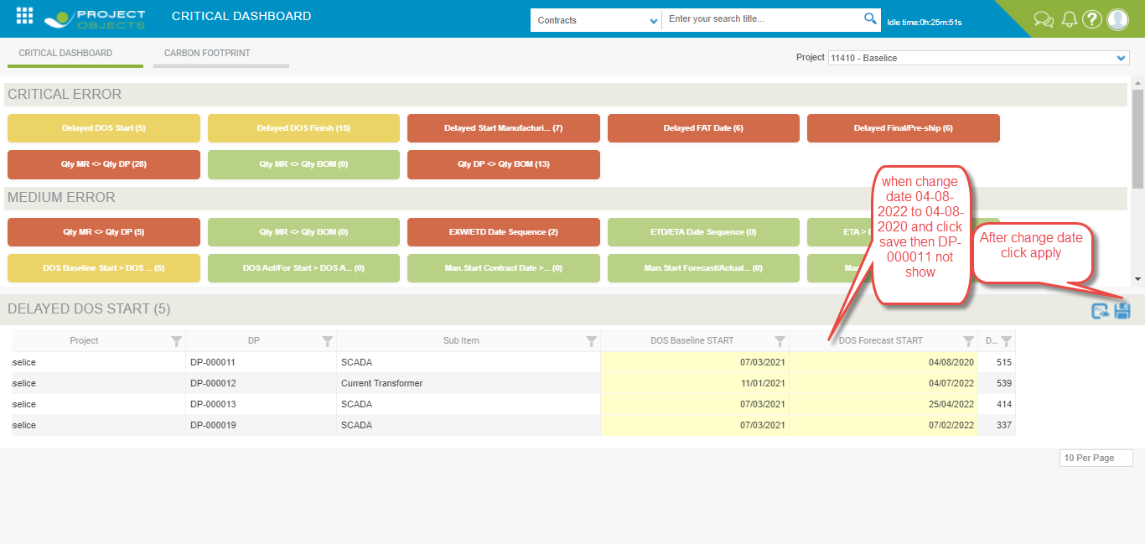

* When DOS Forecast Start < DOS Baseline Start then it should not show in the grid and tile count decrease.

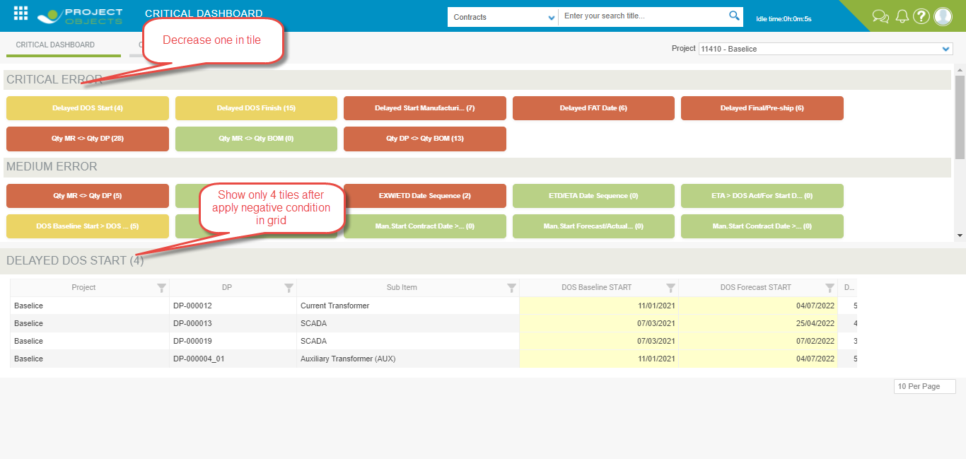

* In go to Project Menu and select the project.

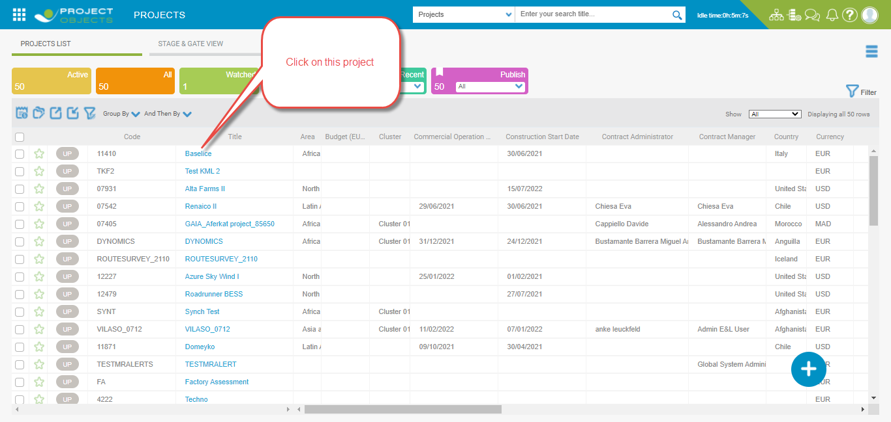

* After clicking on the project then opens a different layout we select the DP layout then show all DP which are available on this project then apply it to customize view for which field is required.

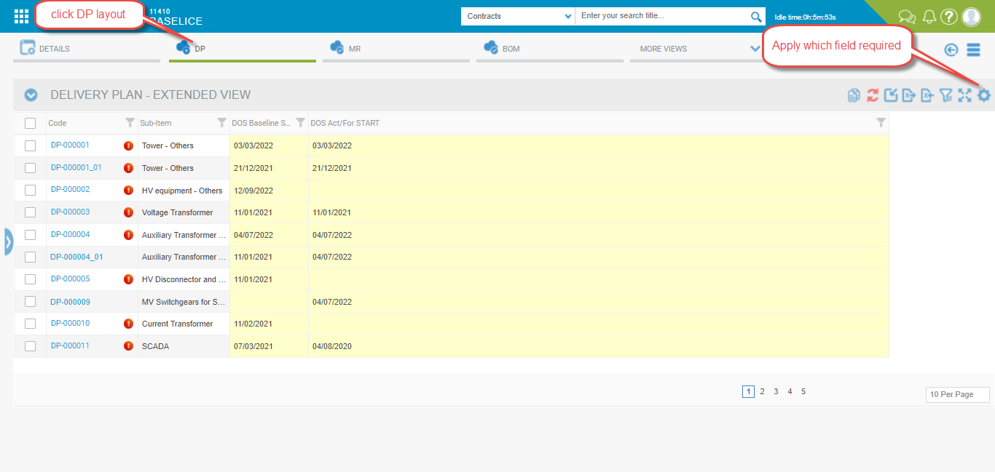

* Apply operation on DP-00001 where DOS Act/for Start<DOS baseline start and not show in dashboard we change the date in DOS Act/For Start and give condition DOS Act/for Start>DOS baseline start then save.

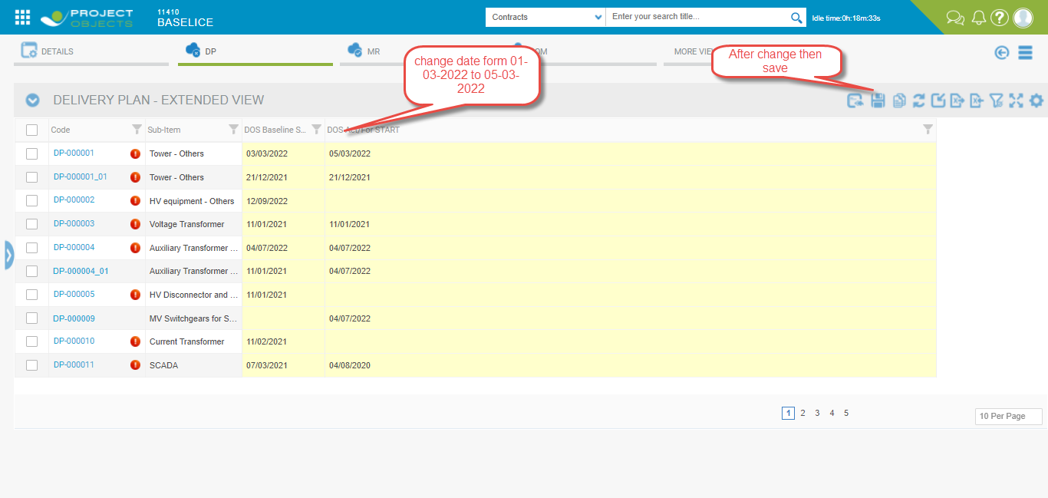

* After save we refresh the dashboard then we show DP-000001 are show in dashboard area.

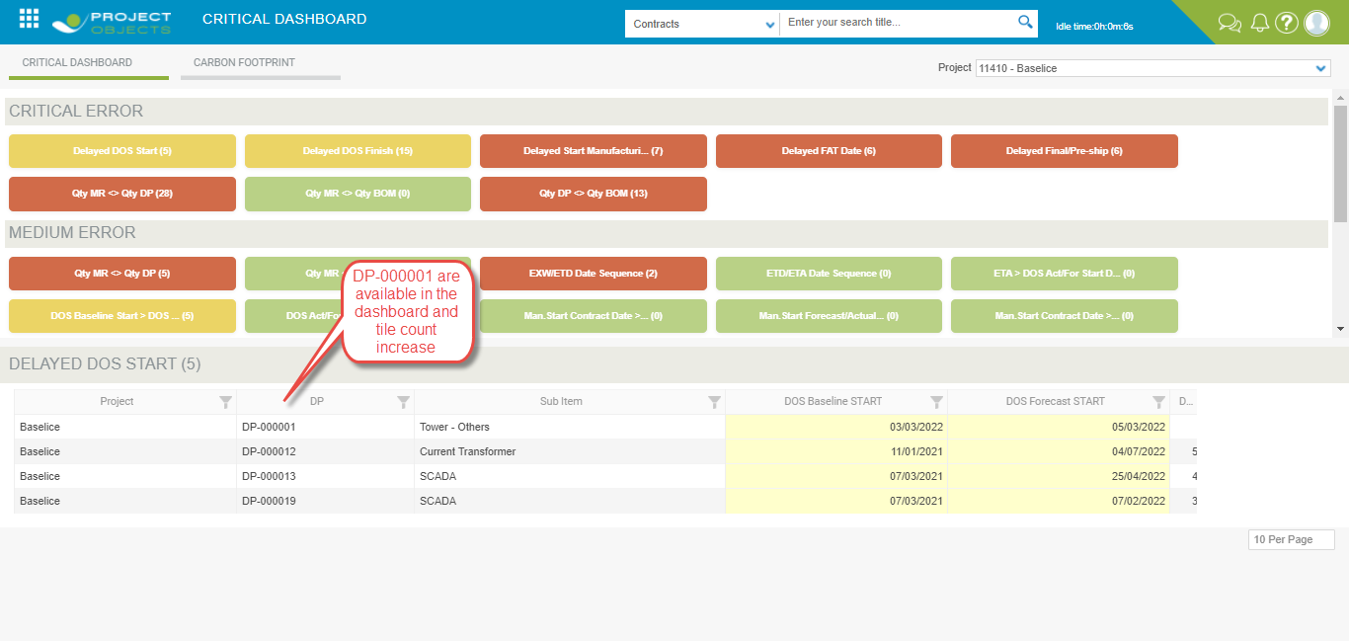

* We can edit DOS baseline Start and DOS Act/For Start from project form we click on highlighted DP-000001 then open a project form.

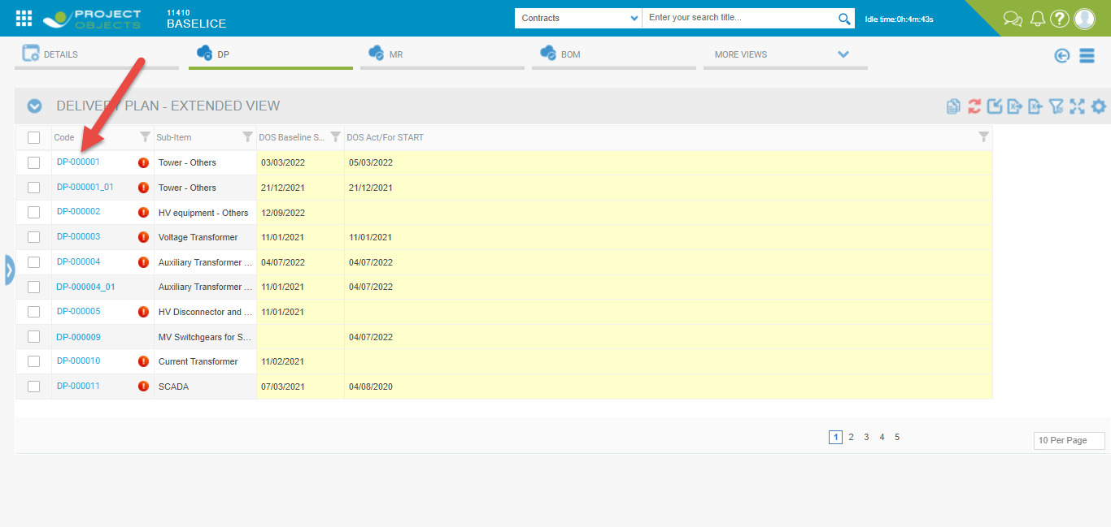

* Project Form open.

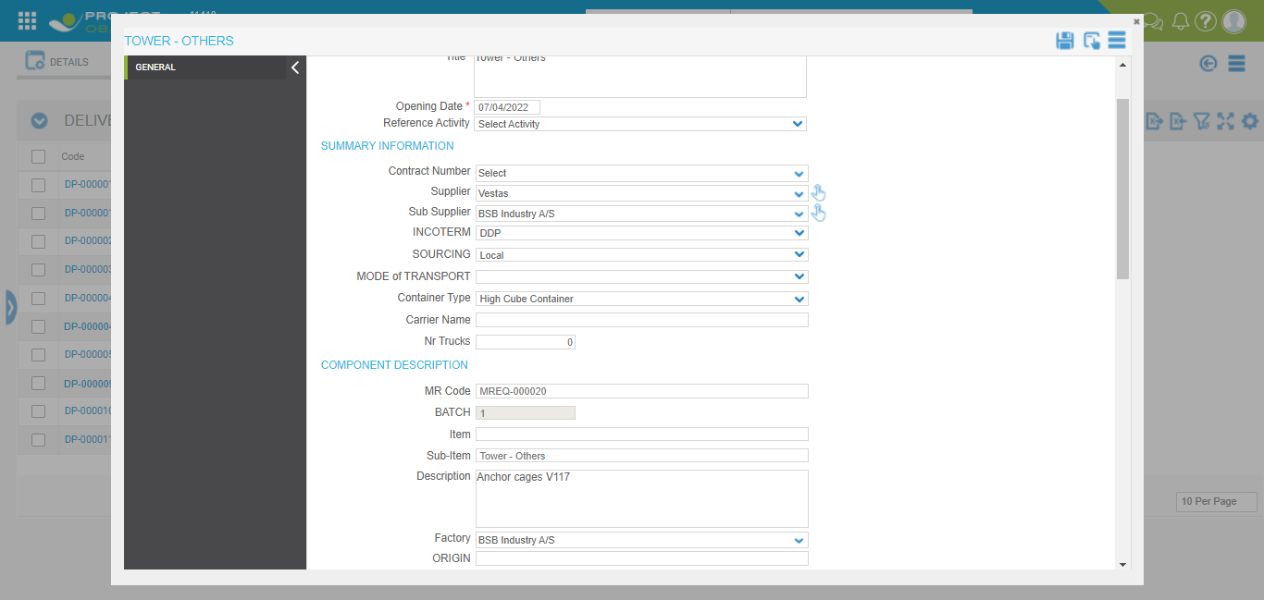

* We can edit the form i.e DOS baseline Start and DOS Act/for Start and then apply and save the changes.

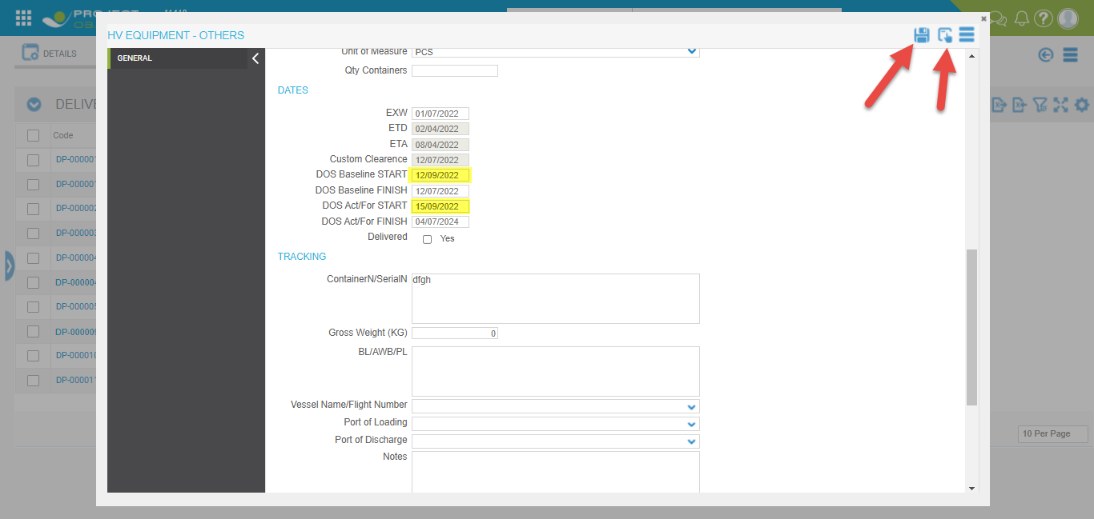

* After apply and save new change are show in DP layout.

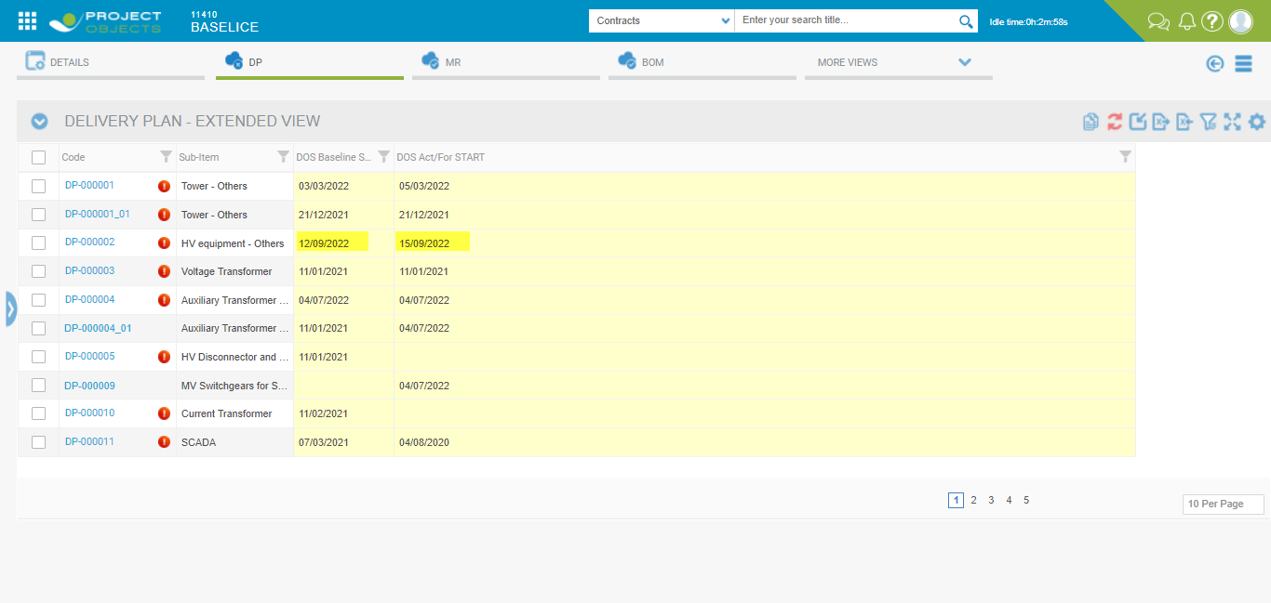

* In DP-000002 DOS Act/for Start>DOS baseline start then it show on dashboard and count increase 5 to 6.

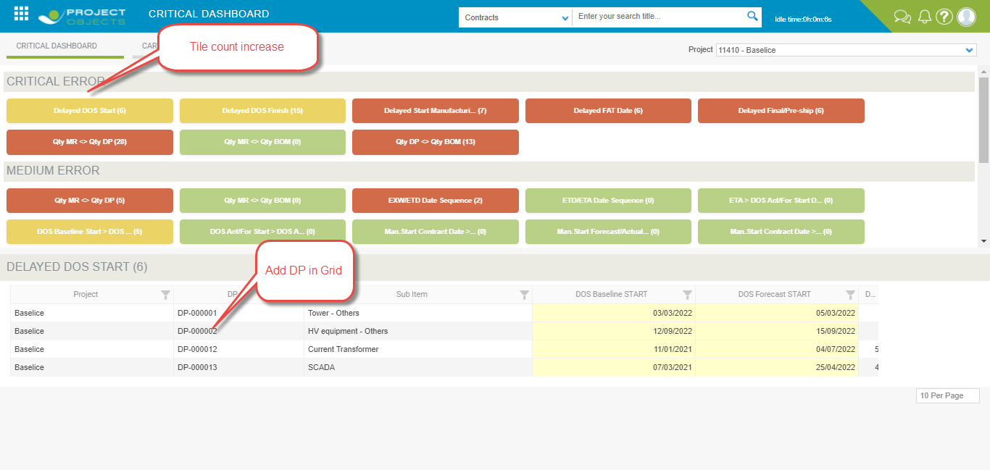

1. **Delayed DOS Finish**

In this tiles we will count all the lines where there is a delay

The delay means when:

DOS forecast FINISH - DOS baseline FINISH >0.

If at least one of the 2 dates is not present it should not be counted as a delay line.

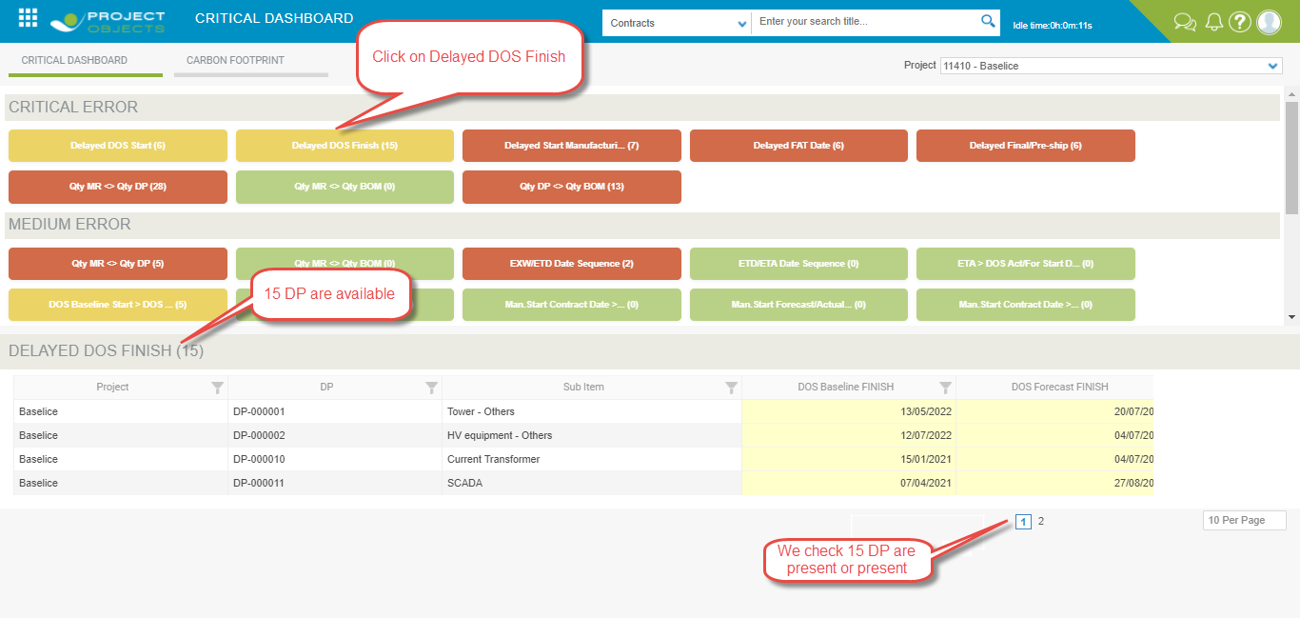

1. **Delayed Start Manufacturing**

In this tiles, we will count all the lines where there is a delay

The delay means when-

Man. Start Forecast/Actual - Man. Start Contract Date > 0

If at least one of the 2 dates is not present it should not be counted as a delay line.

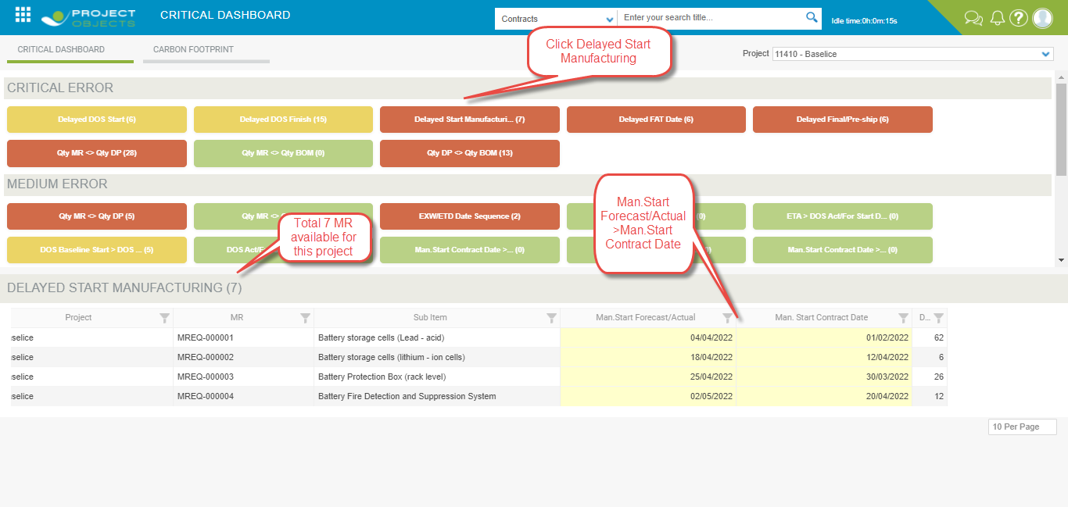

1. **Delayed FAT Date**

In this tiles, we will count all the lines where there is a delay

The delay means when-

Man. FAT Forecast/Actual - Man. FAT Contract Date >0

If at least one of the 2 dates is not present it should not be counted as a delay line

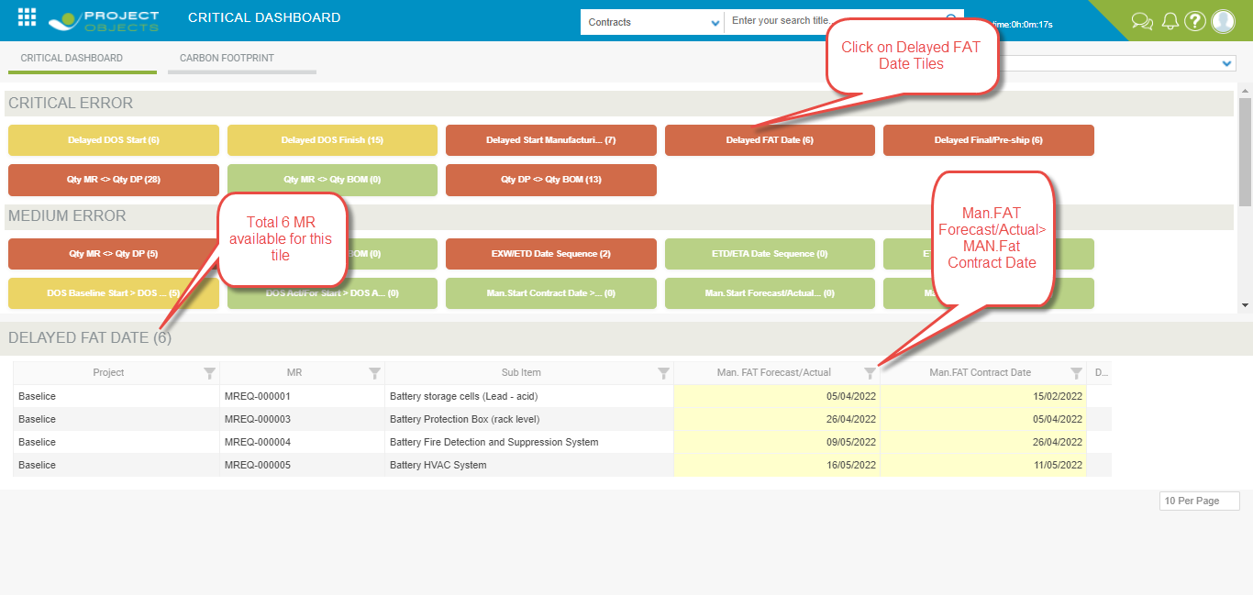

1. **Delayed Final/Pre-ship**

In this tiles, we will count all the lines where there is a delay

The delay means when—

Man. Final/Pre ship. Inst Forecast/Actual - Man. Final/Pre ship. Insp. Contract Date>0

If at least one of the 2 dates is not present it should not be counted as a delay line.

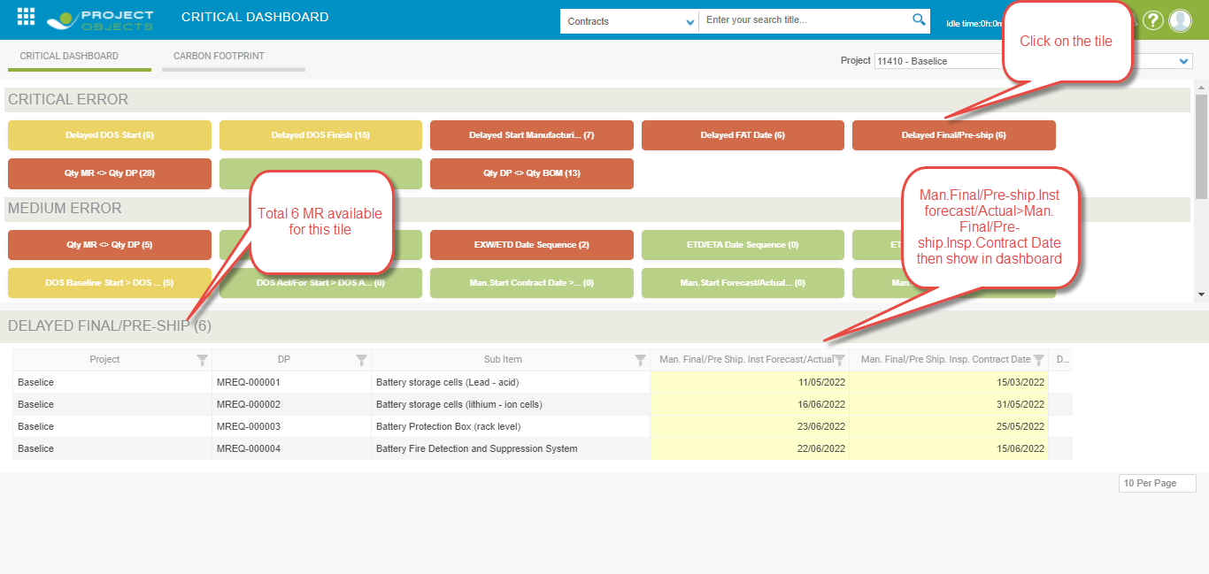

1. **Qty MR <> Qty DP**

The purpose of these tiles is to verify the differences in aggregate quantities for each component present in the MR and DP for Supplier and Sub- supplier. In this case, I could also notice the differences due to the fact that a component is present in the MR and not in the DP and vice versa

If I have multiple rows (for example) of Blade, DC Panel and Tower-T1 in the dashboard I report only one per component aggregating the quantities.

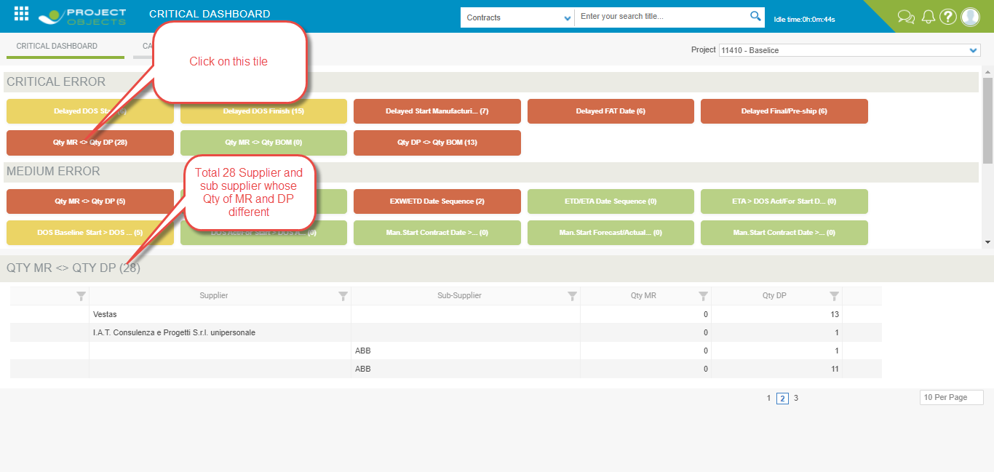

1. **Qty MR <> Qty BOM**

The purpose of this tiles is to verify the differences in aggregate quantities for each component present in the MR and BOM. In this case I could also notice the differences due to the fact that a component is present in the MR and not in the BOM and vice versa (perhaps due to a cancellation by mistake)

If I have multiple rows (for example) of Blade, DC Panel and Tower-T1 in the dashboard I report only one per component aggregating the quantities

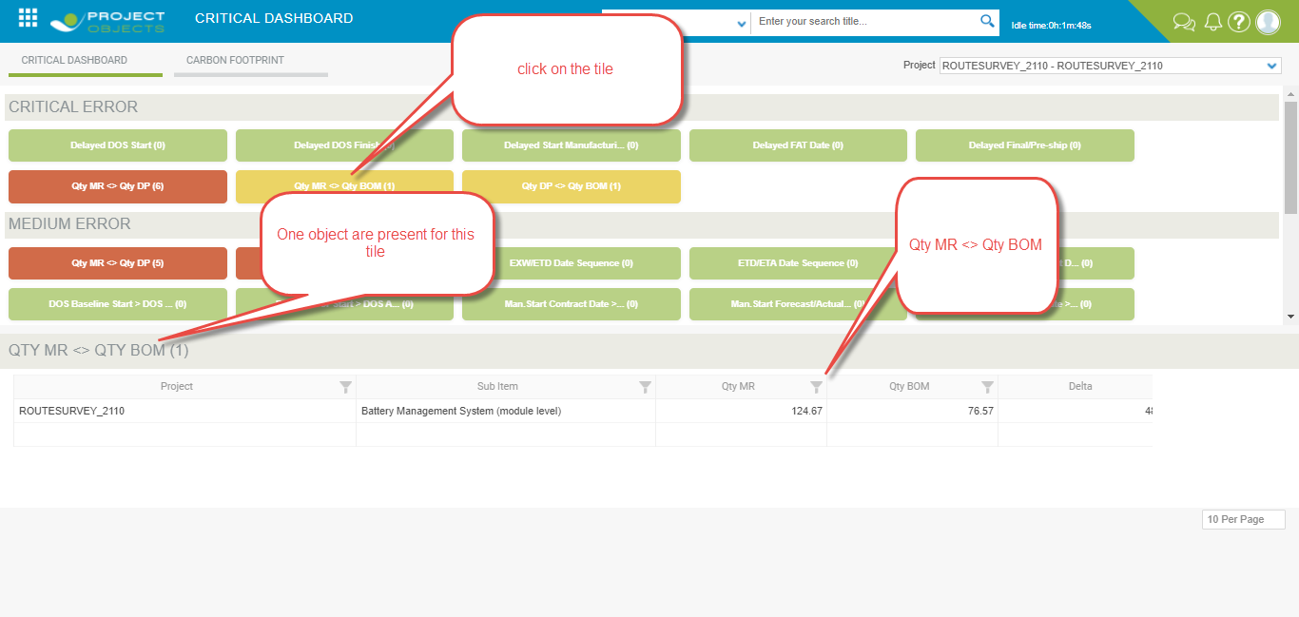

1. **Qty DP <> Qty BOM**

The purpose of these tiles is to verify the differences in aggregate quantities for each component present in the DP and BOM. Since there is no Qty of the DP in the BOM I will have to use the Contractual Qty as a yardstick.

In this case, I could also notice the differences due to the fact that a component is present in the DP and not in the BOM and vice versa (perhaps due to a cancellation by mistake)

If I have multiple rows (for example) of Blade, DC Panel and Tower-T1 in the dashboard I report only one per component aggregating the quantities

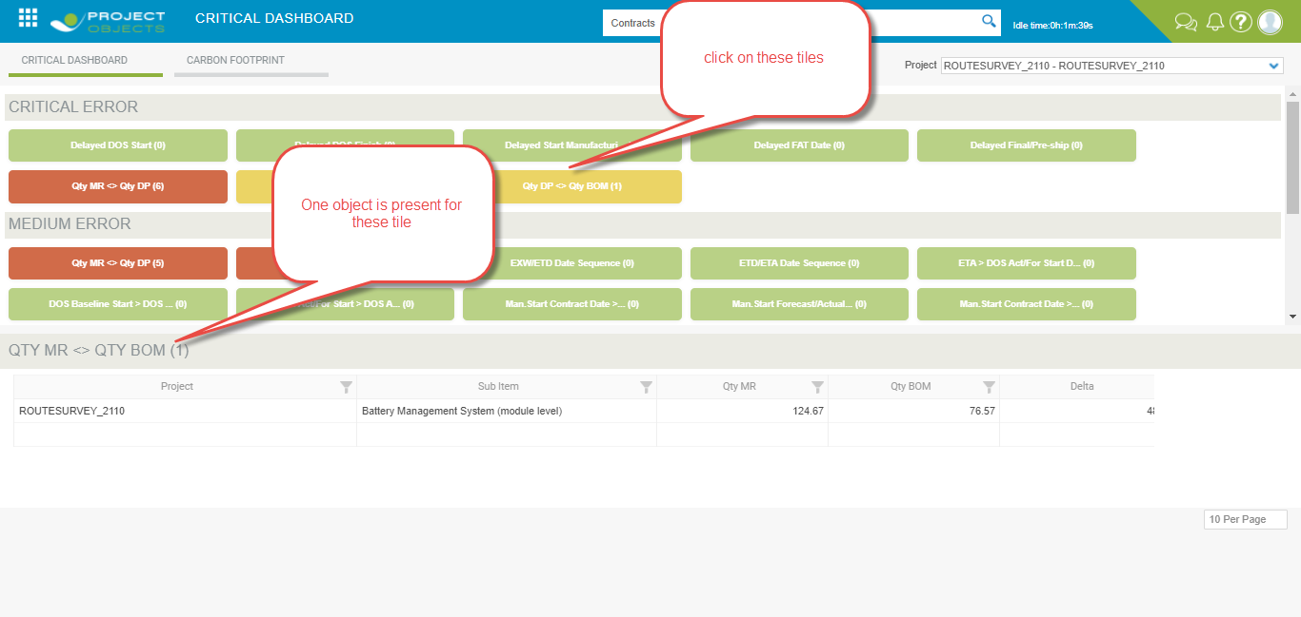

**2- Medium Error**

This paragraph will list all errors that are of average priority to be monitored.

1. **Qty MR <> Qty DP**

In This Tile we show if there is an MR associated with a DP in which the quantity is valued differently.

As a result, only the rows for which there is a match between MR and DP will be shown and the quantity is different.

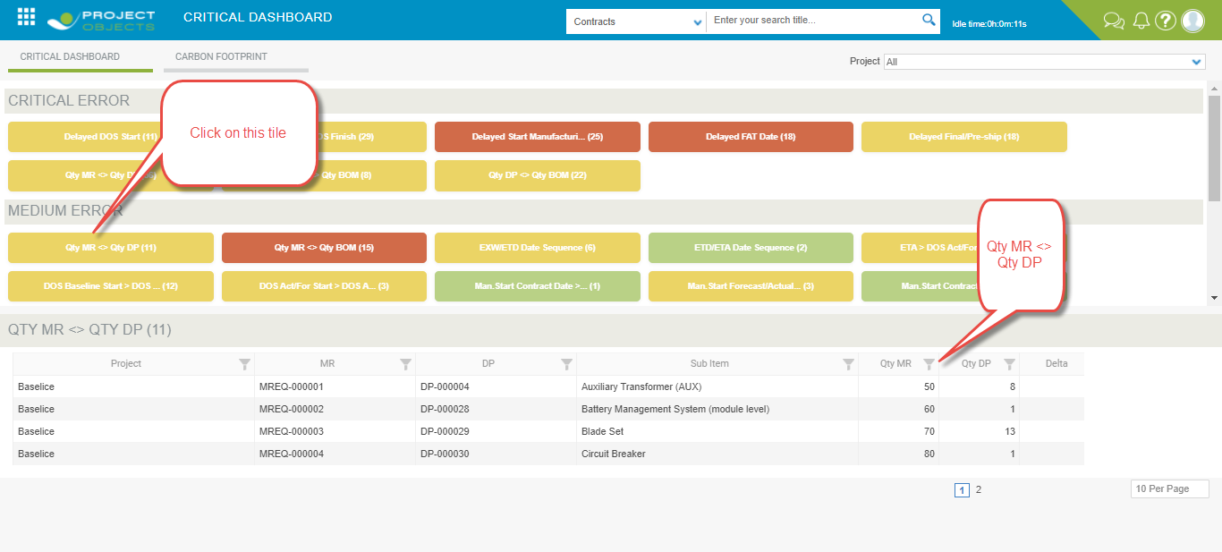

1. **Qty MR<> Qty BOM**

In This Tile we show if there is an MR associated with a BOM in which the quantity is valued differently.

As a result, only the rows for which there is a match between MR and BOM will be shown and the quantity is different.

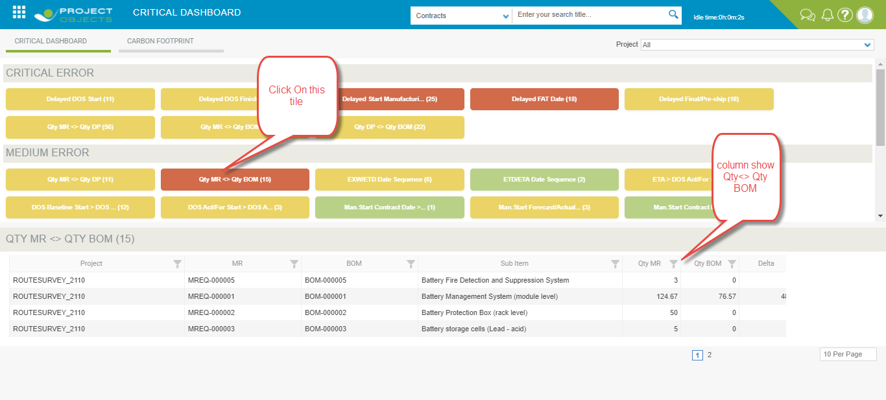

1. **EXW/ETD Date Sequence**

In this specific case I have to verify that EXW > ETD. In case if EXW > ETD then show in thus tiles

Both dates must be valued otherwise I do not have to show the line as tile count.  
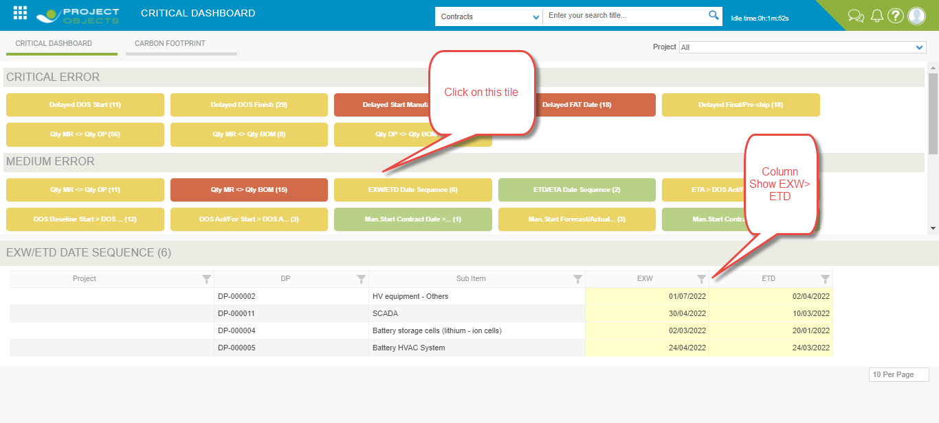

1. **ETD/ETA Date Sequence**

In this specific case I have to verify that ETD > ETA. In case if ETD > ETA then show in thus tiles

Both dates must be valued otherwise I do not have to show the line as tile count.  
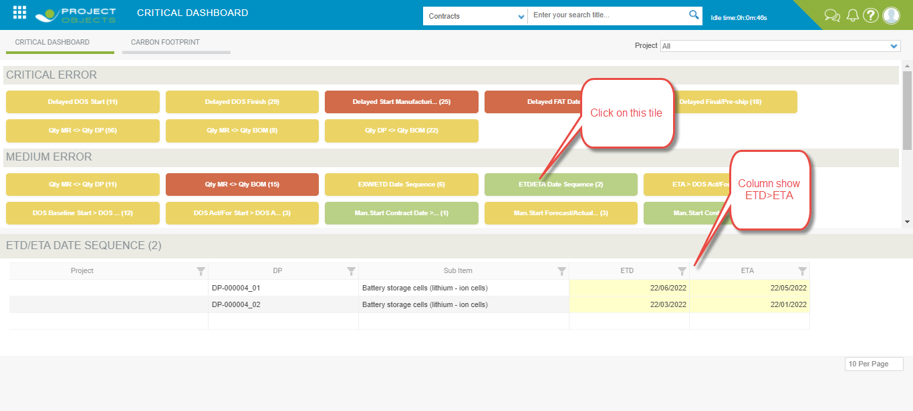

1. **ETA > DOS Act/For Start**

In this specific case I have to check that the ETA >DOS Act/For START . In case it is show and report the tile count.

All dates must be valued otherwise I do not have to report the line as an tile count.

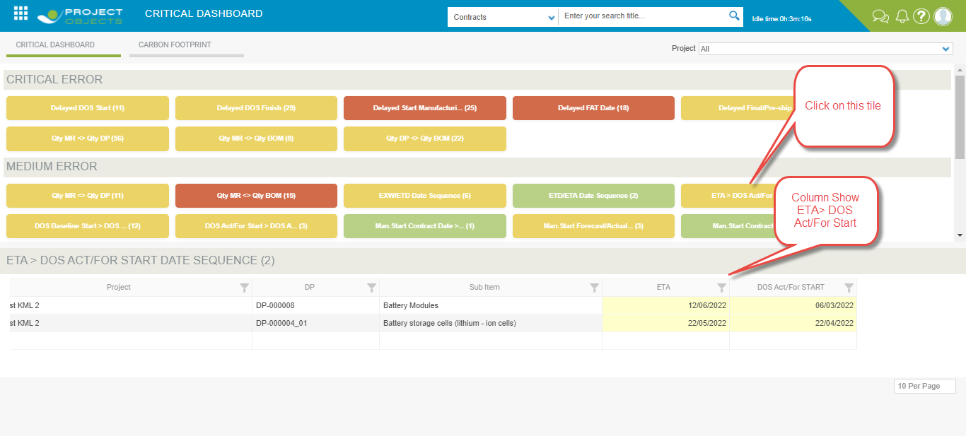

1. **DOS Baseline START > DOS Baseline Finish**

In this specific case I have to check that the **DOS Baseline START > DOS Baseline Finish** . In case it is show and report the tile count.

All dates must be valued otherwise I do not have to report the line as an tile count.

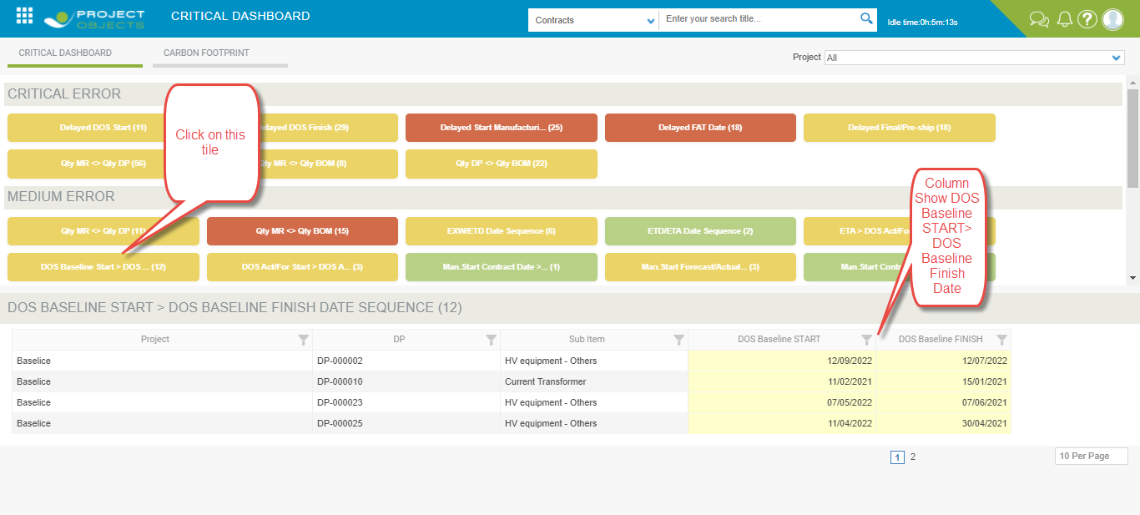

1. **DOS Act/For START > DOS Act/For FINISH**

In this specific case I have to check that the **DOS Act/For START > DOS Act/For FINISH**. In case it is show and report the tile count.

All dates must be valued otherwise I do not have to report the line as an tile count.

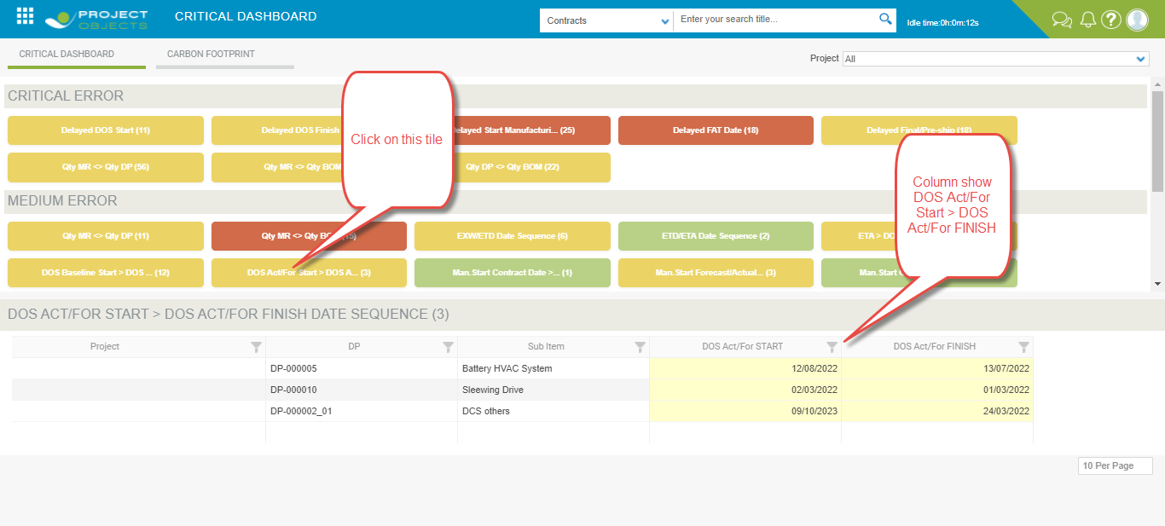

1. **Man. Start Contract Date > Man. FAT Contract Date**

In this specific case I have to check that the **Man. Start Contract Date > Man. FAT Contract Date**. In case it is show and report the tile count.

All dates must be valued otherwise I do not have to report the line as an tile count.

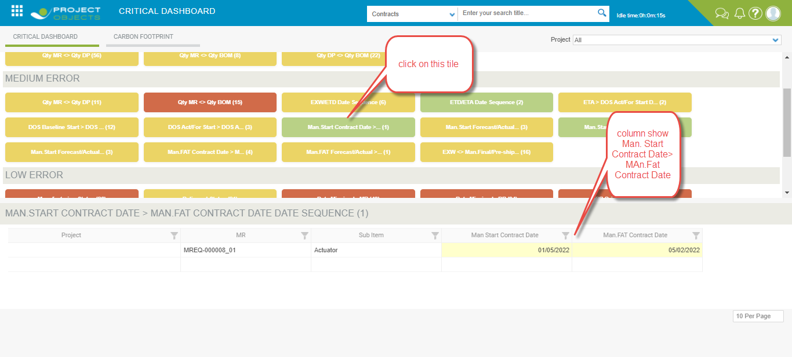

1. **Man. Start Forecast/Actual > Man. FAT Forecast/Actual**

In this specific case I have to check that **Man. Start Forecast/Actual > Man. FAT Forecast/Actual**. In case it is show and report the tile count.

All dates must be valued otherwise I do not have to report the line as an tile count.

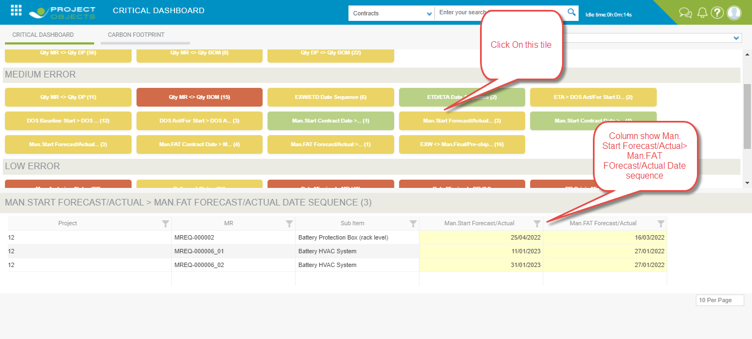

1. **Man. Start Contract Date > Man. Final/Pre-ship Insp. Cont. Date**

In this specific case I have to check **Man. Start Contract Date > Man. Final/Pre-ship Insp. Cont. Date** In case it is show and report the tile count.

All dates must be valued otherwise I do not have to report the line as an tile count.

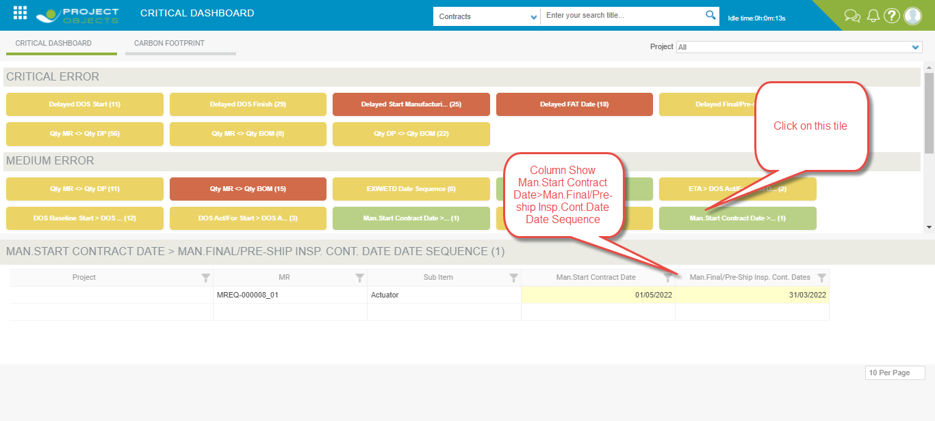

1. **Man. Start Forecast/Actual > Man. Final/Pre-ship Insp. Forecast/Actual**

In this specific case I have to check Man. Start Forecast/Actual > Man. Final/Pre-ship Insp. Forecast/Actual.

In case it is show and report the tile count.

All dates must be valued otherwise I do not have to report the line as an tile count.

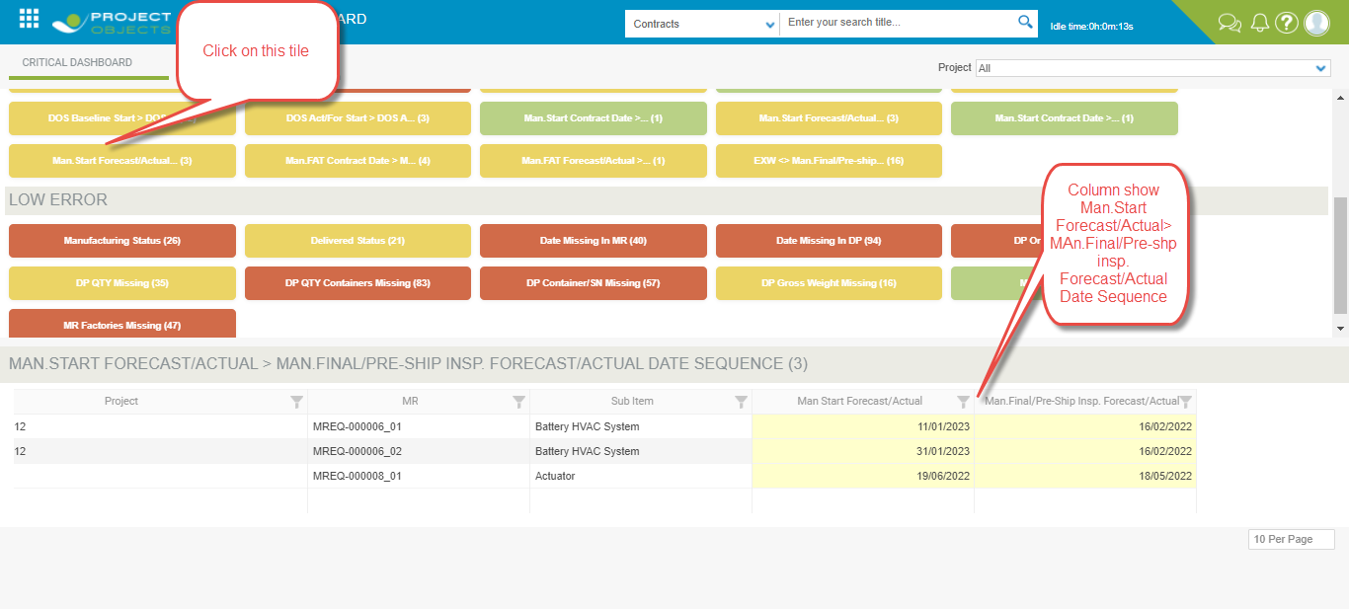

1. **Man. FAT Contract Date > Man. Final/Pre-ship Insp. Cont. Date**

In this specific case I have to check **Man. FAT Contract Date > Man. Final/Pre-ship Insp. Cont. Date**

In case it is show and report the tile count.

All dates must be valued otherwise I do not have to report the line as an tile count.

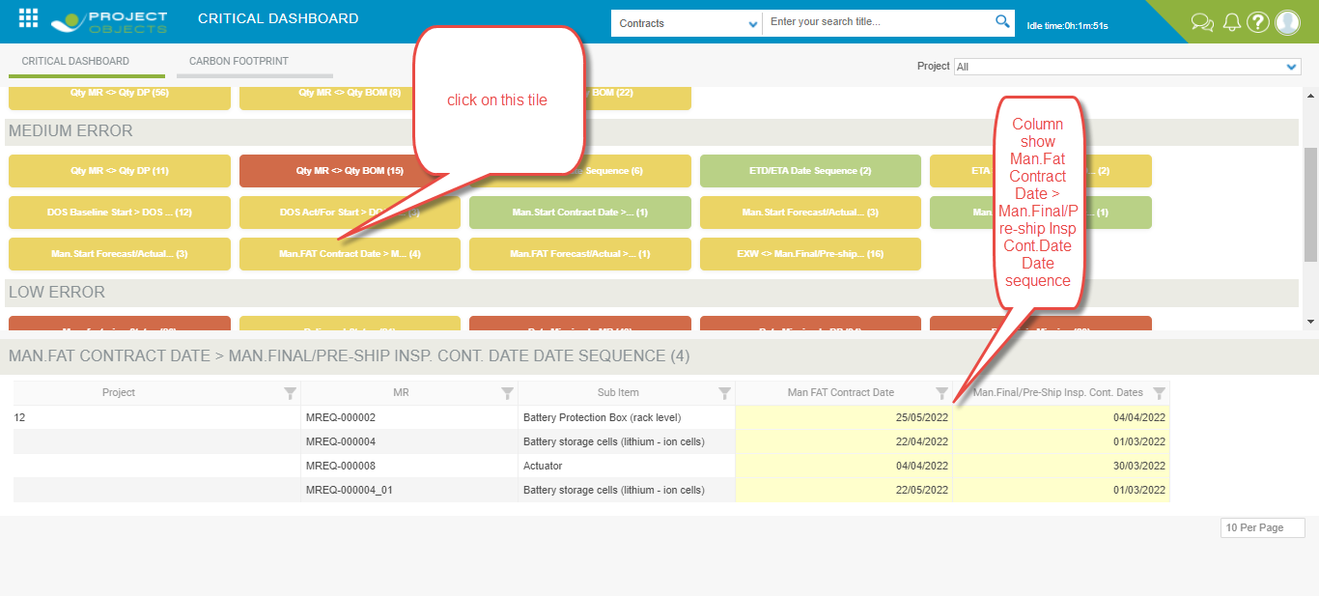

1. **Man. FAT Forecast/Actual > Man. Final/Pre-ship Insp. Forecast/Actual**

In this specific case I have to check **Man. FAT Forecast/Actual > Man. Final/Pre-ship Insp. Forecast/Actual**

In case it is show and report the tile count.

All dates must be valued otherwise I do not have to report the line as an tile count.

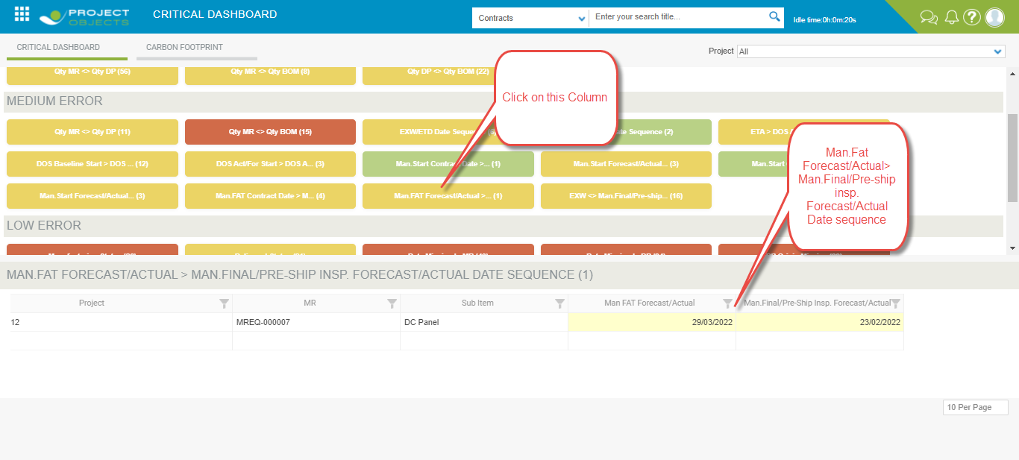

1. **EXW <> Man. Final/Pre-ship Insp. Forecast/Actual**

In this specific case I have to check EXW <> Man. Final/Pre-ship Insp. Forecast/Actual

In case there must be association between MR and DP

All dates must be valued otherwise I do not have to report the line as an tile count.

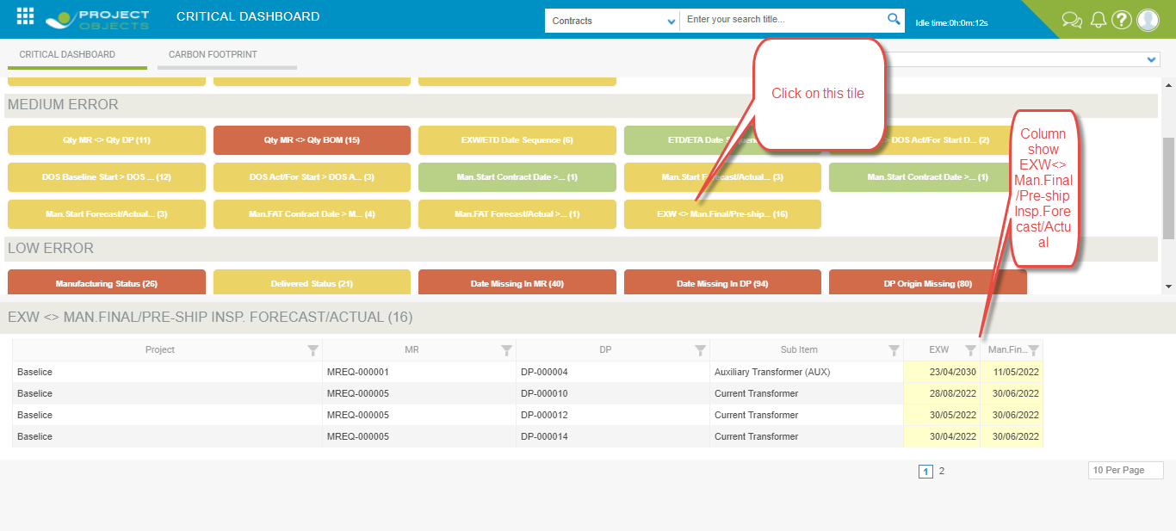

**3- Low Error**

This paragraph will list all errors that are of low priority to be monitored.

1. **Manufacturing Status**

This tiles must count all occurrences that have

Man. Final/Pre-ship Insp. Forecast/Actual < Today Date flag “Working Status” not set.

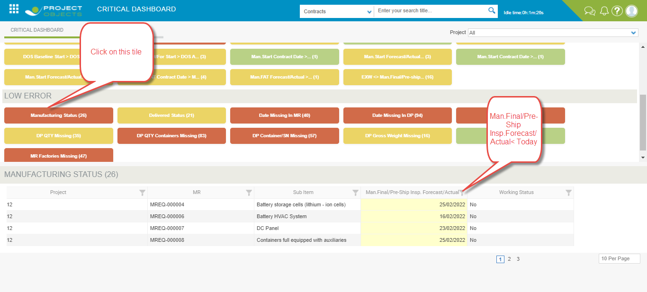

1. **Delivered status**

This tile must count all occurrences that have

DOS Act/For FINISH < Today and flag “Delivered” non set

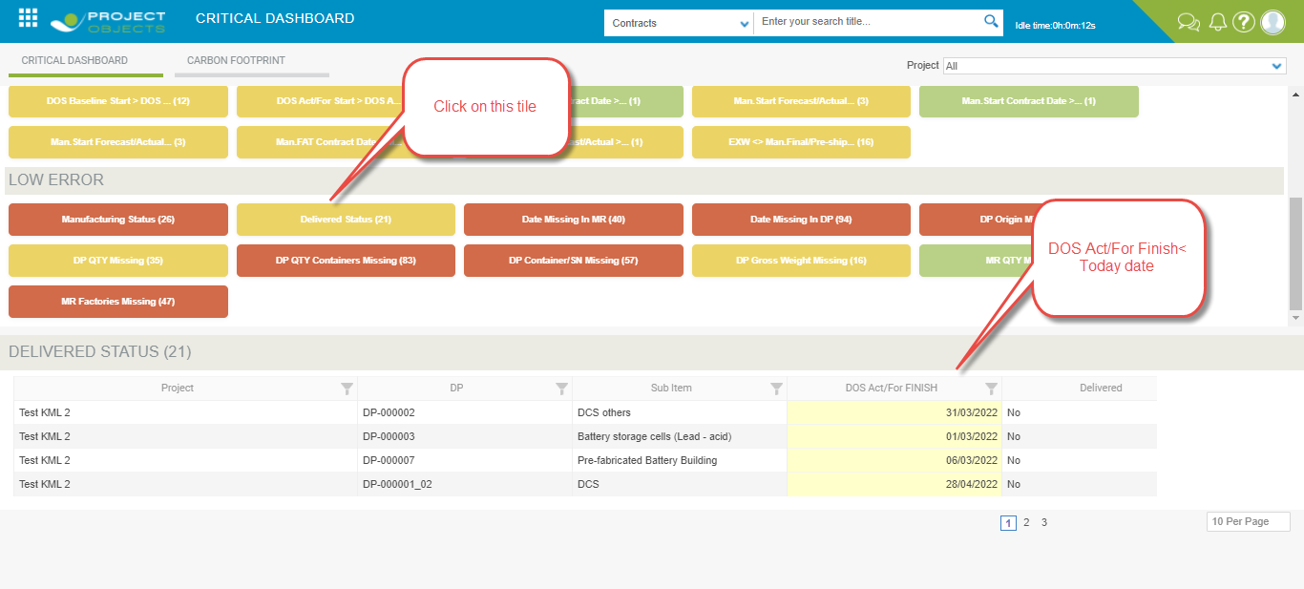

1. **Date Missing in MR**

The purpose of these tiles is to count the number of all empty dates within the MR.

The detailed table must include all the dates in the MR; I will not show a line of MR if and only if all the dates present are populated. Otherwise (even just one missing) I will show the line.

We require a table showing all the MR where a date is missing.

See the example below, Man. FAT forecast/actual is missing then the MR must be counted in the tails.

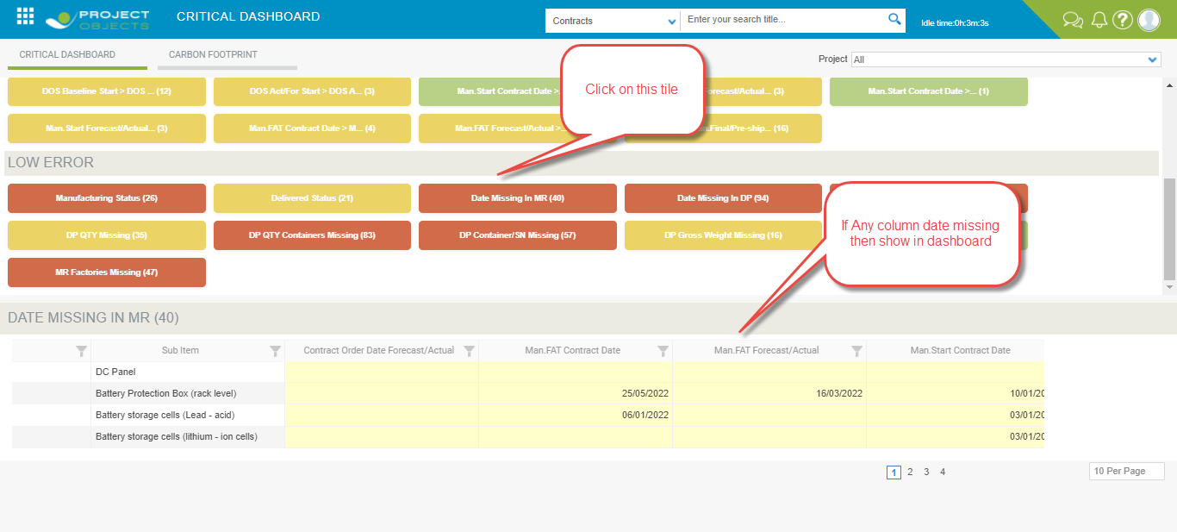

1. **Date Missing in DP**

The purpose of this tiles is to count the number of all empty dates within the DP

The detailed table must include all the dates in the DP; I will not show a line of DP if and only if all the dates are populated. Otherwise (even just one missing) I will show the line.

This must consider when the DP Source field=Local:  
1. If=Local then the objects must be counted only if any of other dates than **ETA, ETD, Custom Clearance** is missing

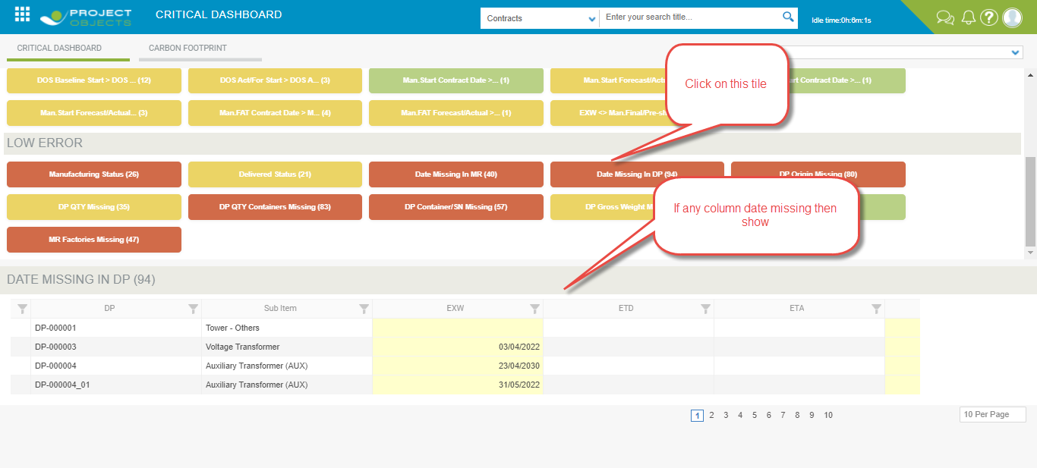

1. **DP Origin Missing**

In this tile we consider which DP whose Origin are missing.

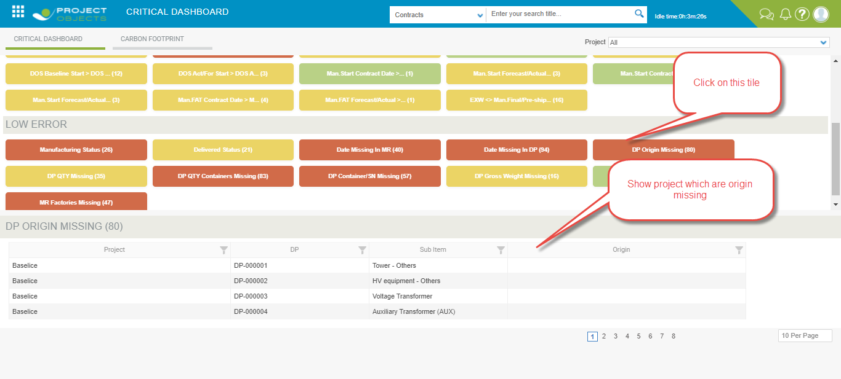

1. **DP Qty Missing**

In this tile we consider DP whose Quantity are missing.

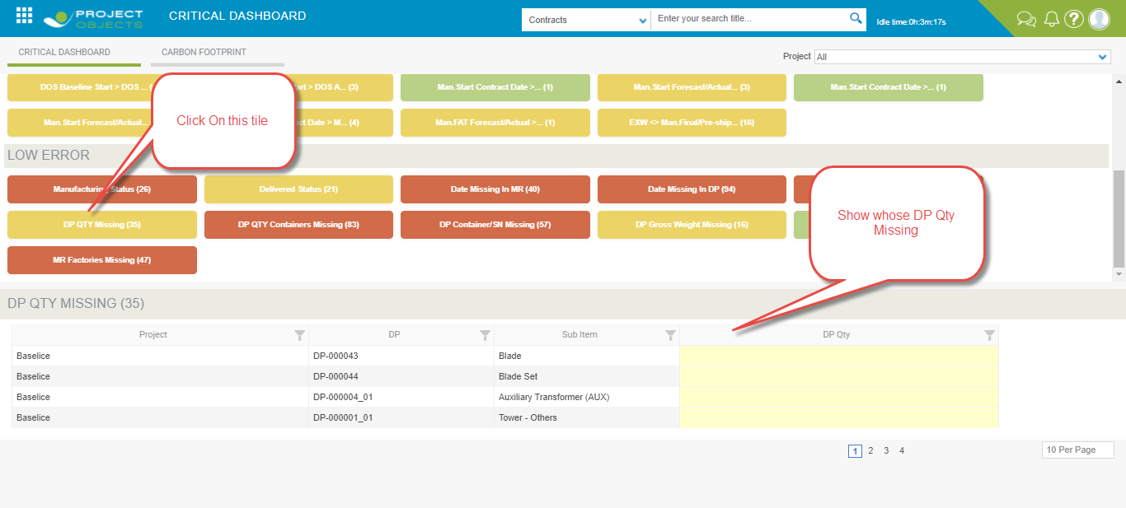

1. **DP Qty Containers Missing**

In this tile we consider whose DP Qty Containers Missing

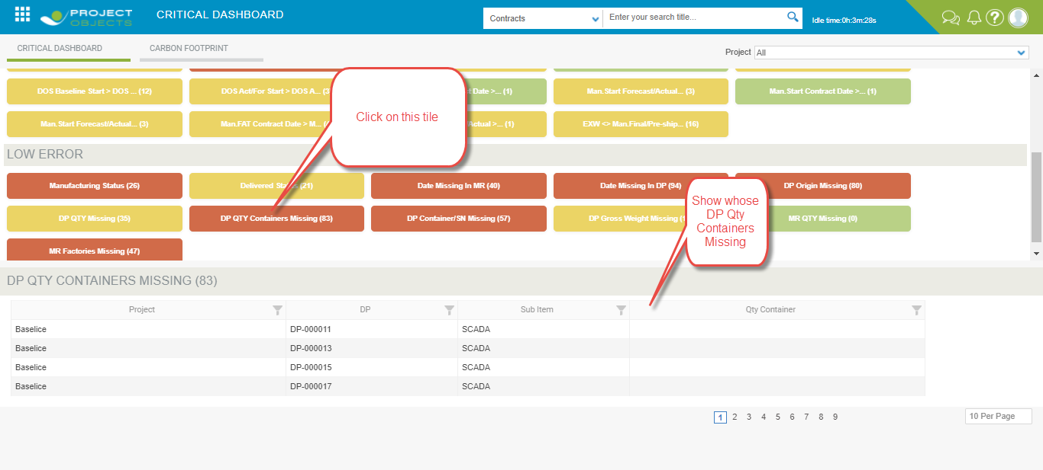

1. **DP Container/SN Missing**

In this tile we consider whose DP Container/SN Missing

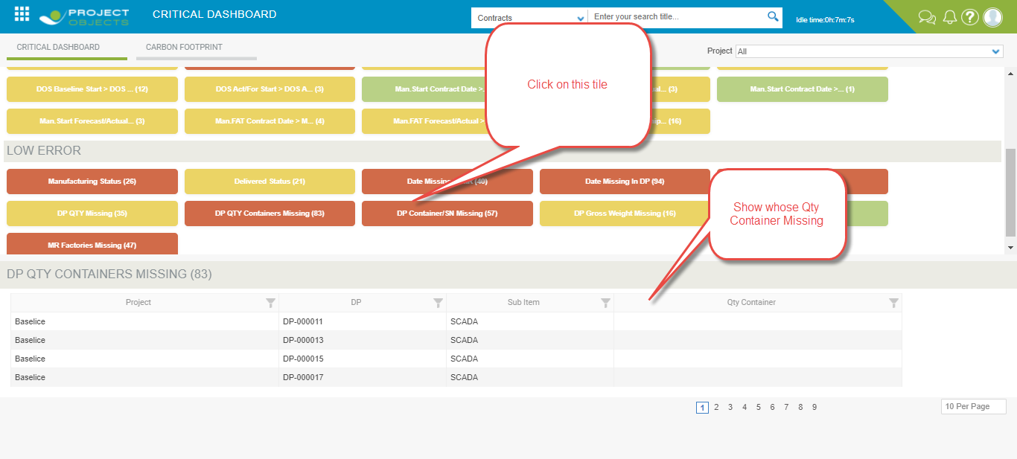

1. **DP Gross Weight Missing**

In this tile we consider whose DP Gross Weight are missing.

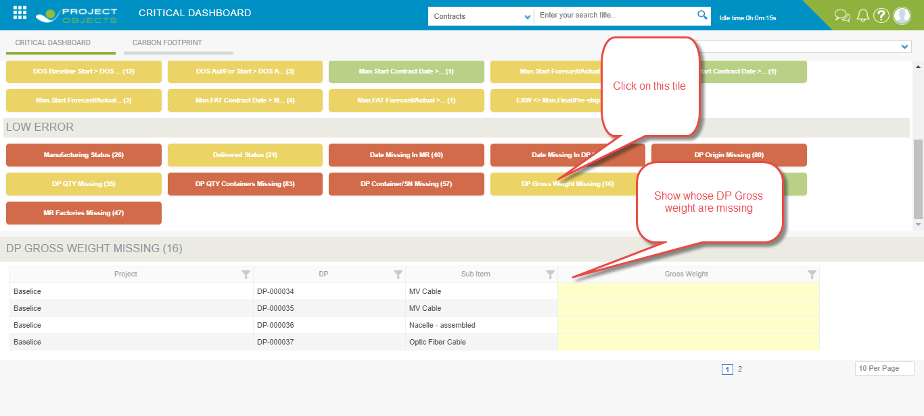

1. **MR Qty Missing**

In this tile we consider MR which QTY are missing.

1. **MR Factories Missing**

In this tile we consider MR which Factory are missing**.**

